4.2 Leaf Cell Description
- Delay
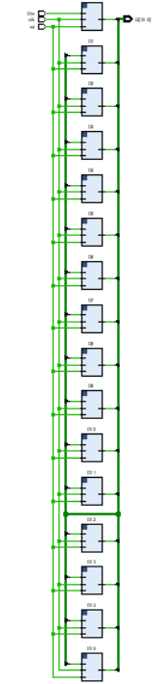

Functionality
module shift_register_16_tb;
reg Din, clk, rst;
wire [15:0] Q;
shift_register_16 uut (Q, Din, clk, rst);
always #5 clk = ~clk;
initial
begin
$monitor("Time=%0t | Din=%b | Q(Binary)=%b",$time, Din, Q);
clk = 0; rst = 1; Din = 0; #10;
rst = 0;
Din = 1; #10;
Din = 1; #10;
Din = 0; #10;
Din = 0; #10;
Din = 0; #10;
Din = 0; #10;
$finish;
end
endmodule

- Optimization used
Shift register implementation to reduce control complexity
Register sharing to save hardware
Efficient clocking to reduce power consumption

- Multiplier
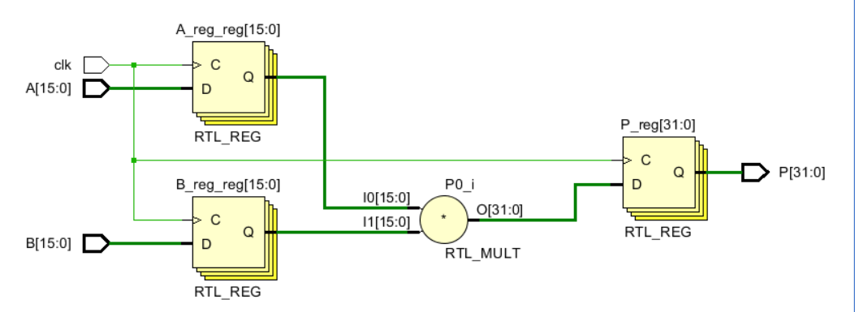

Functionality
module multiplier_tb;
reg signed [15:0] A, B;
wire signed [31:0] P;
multiplier_bit uut (
.A(A),
.B(B),
.P(P)
);
initial
begin
$monitor("Time=%0t | A=%b B=%b | P=%b",$time, A, B, P);
A = 1; B = 1; #10;
A = 2; B = 3; #10;
A = 3; B = 4; #10;
A = 5; B = 2; #10;
A = 6; B = 3; #10;
A = 7; B = 2; #10;
A = 8; B = 3; #10;
A = 9; B = 2; #10;
$finish;
end
endmodule

- Optimization used

Booth’s Algorithm to reduce number of partial products
(Booth’s Algorithm is a technique used in signed binary multiplication to make multiplication)
Use of pipelining to increase speed
Utilization of DSP blocks (in FPGA) for efficient multiplication

- Adder
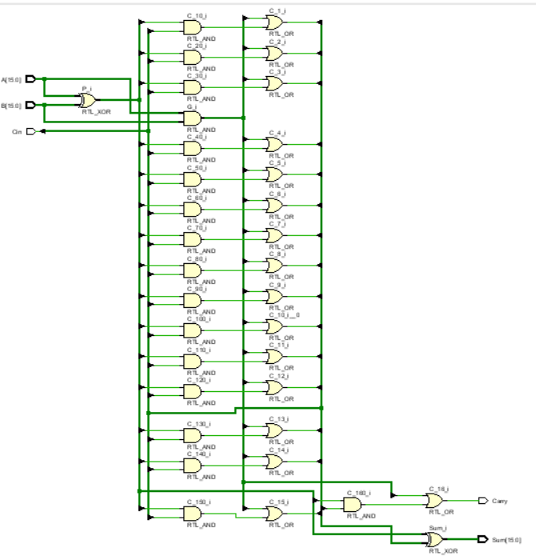
Functionality
module adder_16bit_tb;
reg [15:0] A;
reg [15:0] B;
reg Cin;
wire [15:0] Sum;
wire Carry;
adder_16bit uut (
.A(A),
.B(B),
.Cin(Cin),
.Sum(Sum),
.Carry(Carry)
);
initial
begin
$monitor("Time=%0t | A=%0d B=%0d Cin=%b | Sum=%b Carry=%b",
$time, A, B, Cin, Sum, Carry);
A = 1; B = 1; Cin = 0; #10;
A = 2; B = 3; Cin = 0; #10;
A = 4; B = 5; Cin = 0; #10;
A = 6; B = 2; Cin = 0; #10;
A = 7; B = 1; Cin = 1; #10;
A = 8; B = 1; Cin = 0; #10;
A = 9; B = 9; Cin = 0; #10;
$finish;
end
endmodule

- Optimization used
4-bit Adder for faster operation
Reduced propagation delay
Bit-width optimization to minimize hardware usage

4.3 Leaf Cell Simulation
- Delay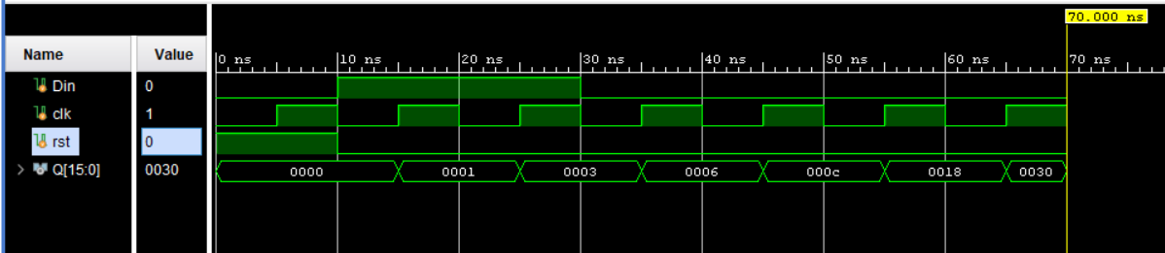

- Input test cases
The reset signal (rst = 1) clears the 16-bit shift register, making all output bits zero. After the reset is removed, the input Din is set to 1 for two clock cycles, so two 1s are inserted into the register. Later, Din is changed to 0, and with every clock pulse the stored bits shift one position to the left while 0 enters from the right side. Because of this shifting operation, the pair of 1s moves left across the register, producing the output sequence 0001, 0003, 0006, 000C, 0018, and 0030, which shows the operation of a 16-bit left shift register.

- Output verification
Time (ns) | clk ↑ | Din | rst | Q[15:0] (Hex) | Q[15:0] (Binary)
0 | Reset | 0 | 1 | 0000 | 0000 0000 0000 0000
10 | ↑ | 1 | 0 | 0001 | 0000 0000 0000 0001
20 | ↑ | 1 | 0 | 0003 | 0000 0000 0000 0011
30 | ↑ | 0 | 0 | 0006 | 0000 0000 0000 0110
40 | ↑ | 0 | 0 | 000C | 0000 0000 0000 1100
50 | ↑ | 0 | 0 | 0018 | 0000 0000 0001 1000
60 | ↑ | 0 | 0 | 0030 | 0000 0000 0011 0000

- Multiplier
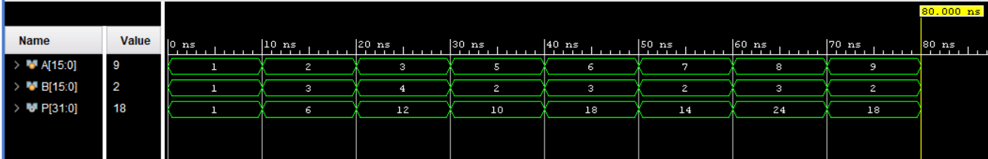

- Input test cases
The input test cases for the 16-bit multiplier circuit were applied by changing the values of inputs A and B at different time intervals. Initially, at time 0, both inputs were given as 1, producing an output product of 1. After every 10 time units, new input combinations were applied to verify the multiplication operation. The test cases included values such as A=2 and B=3 giving output 6, A=3 and B=4 giving output 12, A=5 and B=2 giving output 10, and so on. The inputs were provided in both decimal and 16-bit binary format, while the output product was observed in 32-bit binary format. These test cases help confirm that the multiplier correctly performs multiplication for different combinations of input values and produces the expected output product.

- Output verification
Time | A (Decimal) | B (Decimal) | P = A×B (Decimal) | P (Binary)
0 | 1 | 1 | 1 | 0000_0000_0000_0000_0000_0000_0000_0001
10 | 2 | 3 | 6 | 0000_0000_0000_0000_0000_0000_0000_0110
20 | 3 | 4 | 12 | 0000_0000_0000_0000_0000_0000_0000_1100
30 | 5 | 2 | 10 | 0000_0000_0000_0000_0000_0000_0000_1010
40 | 6 | 3 | 18 | 0000_0000_0000_0000_0000_0000_0001_0010
50 | 7 | 2 | 14 | 0000_0000_0000_0000_0000_0000_0000_1110
60 | 8 | 3 | 24 | 0000_0000_0000_0000_0000_0000_0001_1000
70 | 9 | 2 | 18 | 0000_0000_0000_0000_0000_0000_0001_0010

- Adder
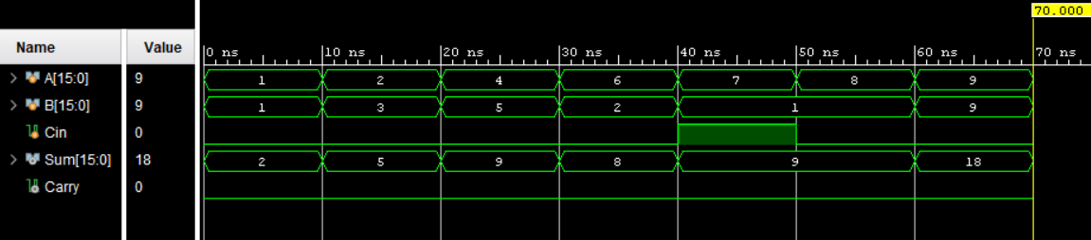

- Input test cases
The test cases for the 16-bit adder use small decimal inputs to verify basic addition functionality and carry behavior. Inputs range from simple values like (1, 1), (2, 3), (4, 5), and (6, 2) to slightly larger cases such as (7, 1 with Cin=1), (8, 1), and (9, 9), all chosen within 1 to 9 for easy understanding. Each test case applies different combinations of A, B, and Cin to check correct sum generation in binary form and to ensure proper carry output. These cases mainly verify normal addition situation where results remain within 16-bit limits, helping confirm correct operation of sum and carry logic in the adder design.

- Output verification
A (Decimal) | B (Decimal) | Cin | Sum (Decimal) | Carry
1 | 1 | 0 | 2 | 0
2 | 3 | 0 | 5 | 0
4 | 5 | 0 | 9 | 0
6 | 2 | 0 | 8 | 0
7 | 1 | 1 | 9 | 0
8 | 1 | 0 | 9 | 0
9 | 9 | 0 | 18 | 0

